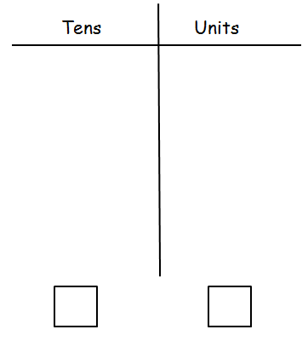**Place Value.**





….. tens and ….. units = ……..

….. ten and ….. units = ……..





….. tens and ….. units = ……..

….. tens and ….. units = ……..



….. tens and ….. units = ……..

….. tens and ….. units = ……..

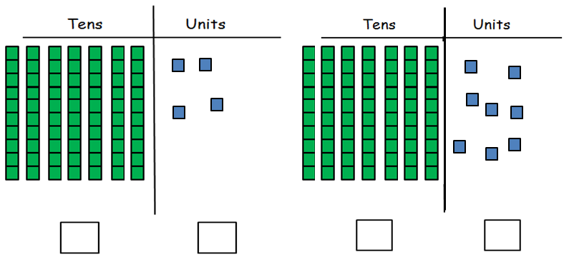

….. tens and ….. units = ……..

….. tens and ….. units = ……..